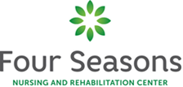

The rates charges by the facility for residency and services, detailed for each nongovernmental payer source. | Private = $400 Semi=$338
All owners of the facility | Jeffrey Goldstein, Lea Sherman, Alexander Sherman, Michael Manela, Hindy Amsel, Shery Frankl, Chanania Pomerantz
The Name and business address if any landlord of the facility | N/A
A summary of all contracts for goods and series for which the facility pays with any portion of Medicaid and Medicare funds, or any other agreement entered into the facility, within 30 days of execution of the agreement or contract. | A complete list of outside vendors Four Seasons Nursing and Rehabilitation Center contracts with is available upon request by calling the facility at 718-927-6300

